A
Data structures and Algorithm Micro Project Report on

STUDENT RECORD MANAGEMENT SYSTEM

Submitted in partial fulfilment of the requirements for the completion of the course

MICRO PROJECT
Submitted by
Ms. SAYEEDA SAMEER TAMBOLI | 1025091923
Ms. ROHINI SAMBHAJI MALI | 1025091029
Ms. AVANTI GANESH DHUMALE | 1025091035
Ms. SHWETA SHANKAR FASAKE | 1025091038

Under the Guidance of
Dr. Asma A. Shaikh

DEPARTMENT OF ARTIFICIAL INTELLIGENCE AND DATA SCIENCE

Sant Dnyaneshwar Shikshan Sanstha's
ANNASAHEB DANGE COLLEGE OF ENGINEERING AND TECHNOLOGY, ASHTA
(An Empowered Autonomous Institute)

SHIVAJI UNIVERSITY, KOLHAPUR
Academic Year: 2026-267
Sant Dnyaneshwar Shikshan Sanstha's
ANNASAHEB DANGE COLLEGE OF ENGINEERING AND TECHNOLOGY, ASHTA
DEPARTMENT OF ARTIFICIAL INTELLIGENCE AND DATA SCIENCE
CERTIFICATE
This is to certify that the Mini Project report entitled “STUDENT RECORD MANAGEMENT SYSTEM ” is a bonafide work carried out by the following student(s):

URN | Name of Student
1025091023 | Sayeeda Sameer Tamboli
1025091029 | Rohini Sambhaji Mali
1025091035 | Avanti Ganesh Dhumale
1025091038 | Shweta Shankar Fasake

in partial fulfilment of the requirements for the completion of the Mini Project course for the Second Year, Bachelor of Technology in DEPARTMENT OF ARTIFICIAL INTELLIGENCE AND DATA SCIENCE at Annasaheb Dange College of Engineering and Technology, Ashta, for the Academic Year 2026–27.
Place: Ashta
Date: / /

Course coordinator

ACKNOWLEDGEMENT

We express our sincere gratitude to our Micro Project Guide, Dr. Asma A. Shaikh for her invaluable guidance, constant support, and encouragement throughout the completion of our Mini Project work.
We are also deeply thankful to the Head of the Department, Dr. Asma A. Shaikh DEPARTMENT OF ARTIFICIAL INTELLIGENCE AND DATA SCIENCE, for their continuous guidance, valuable suggestions, and unwavering support, which greatly helped us in overcoming various challenges during the course of this Mini Project.
Our heartfelt thanks are extended to our Hon. Director, Dr. L. Y. Waghmode, for providing us with the necessary facilities and a motivating environment that enabled us to carry out our Mini Project work successfully. We would also like to express our appreciation to all the faculty members, staff and management of Annasaheb Dange College of Engineering and Technology, Ashta, for their cooperation and assistance throughout this journey.
Finally, we wish to convey our deep gratitude to our friends and family members for their constant encouragement, understanding, and moral support, which played a vital role in the successful completion of this Mini Project.

Sayeeda Sameer Tamboli
Rohini Sambhaji Mali
Avanti Ganesh Dhumale
Shweta Shankar Fasake

ABSTRACT

Abstract

The Student Record Management System is a menu-driven application developed using the C programming language to demonstrate the practical use of data structures and algorithms in maintaining student information. Manual record management can be time-consuming and may lead to duplicate entries, difficulty in searching, and errors while updating or retrieving information. The proposed system provides basic operations such as adding a student record, displaying all records, searching by roll number, modifying student details, deleting a record, and sorting records by roll number. A structure is used to group fields such as roll number, name, course, semester and marks, while an array stores multiple student records in memory. Linear search is used to locate a record, and bubble sort is used to arrange records in ascending order of roll number. The graphics.h library and BGI graphics driver are used to create a simple graphical heading and menu screen, making the application easier to understand and demonstrate. The program is intended as an educational prototype and can be extended with file handling to preserve records between executions. The project demonstrates how structured programming, arrays, structures, searching, sorting and basic graphics can be combined to solve a small administrative problem. The final implementation should be compiled with a compatible graphics environment and tested with valid and invalid inputs before submission.
Keywords: C programming, Data Structures, Student Records, graphics.h, BGI Driver, Array, Structure, Linear Search, Bubble Sort.

TABLE OF CONTENTS
1. Certificate i
2. Acknowledgement ii
3. Abstract iii
4. Introduction 1
5. Problem Statement 2
6. Literature Survey 3
7. System Requirements 4
7.1 Hardware Requirements 4
7.2 Software Requirements 5
8. System Design / Proposed Methodology 6
8.1 Data Structures Used 6
8.2 Algorithms Used 7
8.3 Flowchart 8
8.4 Pseudocode / Algorithm Steps 9
8.5 Module Description 10
9. Implementation 11
9.1 Program Code 11
9.2 Operations Implemented 13
9.3 Time and Space Complexity Analysis 14
9.4 Screenshots 15
10. Results / Output 16
10.1 Sample Input and Output 16
10.2 Test Cases 17
10.3 Performance Analysis / Comparison of Algorithms 18
11. Applications 19
12. Advantages & Limitations 20
12.1 Advantages 20
12.2 Limitations 21
13. Conclusion 22
14. Future Scope 23
15. References 24
16. Appendix 25

1. INTRODUCTION
Student record management systems form the operational backbone of academic departments, registrar offices, and institutional analytics platforms. Efficient tracking of student credentials, departmental affiliations, semester progressions, and cumulative Grade Point Averages (GPA) requires fundamental data structures capable of managing dynamic data scaling.
While elementary static structures such as arrays are simple to implement, they impose strict architectural limitations. Fixed array sizes lead to memory wastage or stack overflow, and inserting or deleting student records in a sorted array demands continuous memory shifting costing O(N) time. Conversely, dynamic non-contiguous structures such as Singly Linked Lists (SLL) resolve memory allocation bottlenecks by generating independent node blocks on the heap as records are created.
A Singly Linked List (SLL) organizes elements sequentially through node structures containing data payloads and single directional pointer references (next). Memory allocation is dynamic, allowing seamless insertion and deletion without requiring memory reallocation or array shifting.
The Student Record Management System combines an SLL C++ backend with an interactive WinBGIm graphical user interface formatted in a Cyber Sapphire & Electric Cyan visual theme. It provides visual linked list canvas rendering, interactive mouse/keyboard navigation, overlay modal text inputs, local file auto-synchronization (students_sll_v2.csv), and one-click formatted Microsoft Excel spreadsheet exporting (student_records_export.csv).
2. PROBLEM STATEMENT
Conventional student record desktop applications exhibit three major design and operational limitations:
1. Memory Allocation Bottlenecks: Using contiguous static arrays leads to fixed storage capacity bounds and high insertion/deletion latency O(N) due to manual element shifts.
2. Lack of Visual Structural Representation: Standard command-line software fails to visualize dynamic node pointer connections (HEAD -> Node -> NULL), leaving pointer manipulation abstract and opaque.
3. Absence of Interoperable Export Tools: Prototypes frequently store records in unformatted text files or volatile RAM, lacking integration with standard spreadsheet applications like Microsoft Excel.
Objective: To design, implement, and evaluate an interactive graphical C++ application using a Singly Linked List (SLL) to manage student academic records, featuring dynamic visual node chaining, in-window text input modals, real-time class analytics, local CSV flat-file persistence, and automated Excel spreadsheet exporting.
3. LITERATURE SURVEY
Author / Study | Focus Area | Methodology | Key Findings | Limitations Identified
Cormen et al. (2009) | Fundamental Data Structures | Theoretical analysis of dynamic pointer allocation and linear lists. | Dynamic linked allocation eliminates array shifting overhead. | Focuses on theoretical concepts without visual GUI implementation.
Kruse & Tondo (2006) | Data Structures in C/C++ | Pointer-based list traversals, node insertion, and pointer re-linking. | Linear traversal yields ordered sequences without secondary sorting algorithms. | Console-bound implementations without persistent storage bridges.
Pai et al. (2018) | Visual Algorithm Simulation | Graphical rendering of node structures and directional edge connections. | Visual node representations enhance algorithmic comprehension. | Rendering flicker observed without double-buffered page switching.
4. SYSTEM REQUIREMENTS
4.1 Hardware Requirements
• Processor: Intel Core i3 (6th Gen, 2.0 GHz) or equivalent AMD processor.
• System Memory (RAM): 4 GB minimum (8 GB recommended).
• Hard Disk Storage: 50 MB free disk space.
• Display Output: SVGA Color Monitor with minimum 1024×768 resolution.
• Input Devices: Standard QWERTY Keyboard and Optical Mouse.
4.2 Software Requirements
• Operating System: Microsoft Windows 10 / Windows 11 (64-bit).
• Programming Language: C++ (GCC / MinGW C++ Compiler Toolchain).
• Integrated Development Environment (IDE): Dev-C++ 5.11, VS Code, or Code::Blocks.
• Graphics Library: WinBGIm (Windows Port of Borland Graphics Interface graphics.h).
• External Application: Microsoft Excel or compatible spreadsheet viewer.
• Linker Libraries: -lbgi -lgdi32 -lcomdlg32 -luuid -loleaut32 -lole32.
5. SYSTEM DESIGN / PROPOSED METHODOLOGY
5.1 Data Structures Used
The core data structure is a dynamically allocated Singly Linked List (SLL) node:
typedef struct StudentNode {
int rollNo; // Primary Key: Roll Number (for sorted placement)
char name[30]; // Payload: Student Name
char dept[20]; // Payload: Department Tag
int semester; // Payload: Current Semester (1-8)
float gpa; // Payload: Grade Point Average (0.0 - 10.0)
char status[10]; // Payload: Academic Status ("PASS" / "FAIL")
struct StudentNode *next; // Pointer: Reference to Next SLL Node in Memory
} StudentNode;
5.2 Algorithms Used
Operation | Algorithm Logic | Target Structure | Computational Purpose
Sorted Insertion | Linear search for position by Roll No; re-link pointers | SLL Node Pointers | Inserts record in ascending roll order without full list re-sorting.
Linear Search | Sequential pointer traversal (curr = curr->next) | SLL Node Pointers | Navigates list sequentially to locate matching Roll No or Student Name.
Node Deletion | Locate target node; bypass link (prev->next = curr->next) | SLL Node Pointers | Removes node from memory (free) and re-links preceding and succeeding nodes.
Record Update | Locate node by Roll No; mutate payload attributes | SLL Node Payload | Updates name, department, semester, or GPA while retaining key order.
Analytics Scan | Single-pass linear traversal with accumulation | SLL Data Payload | Computes Class Average GPA, Pass/Fail totals, and identifies Class Topper.
Page Flipping | Double-Buffering (setactivepage / setvisualpage) | Screen Buffers | Eliminates visual flicker during real-time graphical redrawing.
5.3 Flowcharts & Block Diagrams
Figure 1: System Architecture Block Diagram
(Depicts User Interface Layer, SLL Core Logic Engine, and Persistence Storage Buffer)
Figure 2: Execution Flowchart of SLL Operations & Event Loop
(Displays execution flow across Startup CSV load, Main GUI Loop, Action Dispatching, and Exit)
Figure 3: Data Structure Memory Layout Representation
(Illustrates StudentNode memory blocks, payload fields, pointer links, and HEAD -> Node -> NULL layout)
5.4 Pseudocode / Algorithm Steps
Algorithm 1: Sorted Singly Linked List Insertion
Algorithm InsertSorted(head, rollNo, name, dept, semester, gpa):
newNode = Allocate Memory for StudentNode
Populate newNode fields; set status = (gpa >= 4.0 ? "PASS" : "FAIL")
newNode.next = NULL
If head is NULL Or rollNo < head.rollNo Then:
newNode.next = head
Return newNode
EndIf
current = head
While current.next is Not NULL And current.next.rollNo < rollNo Do:
current = current.next
EndWhile
newNode.next = current.next
current.next = newNode
Return head
End Algorithm
5.5 Module Description
1. SLL Core Logic Engine: Handles node creation, dynamic memory allocation (malloc), pointer re-linking, sequential searching, node updating, and heap memory cleanup (free).
2. File Persistence & Excel Bridge: Synchronizes application state. Auto-saves changes to students_sll_v2.csv and generates formatted Microsoft Excel CSV reports (student_records_export.csv).
3. Cyber Sapphire Graphics Engine: Renders visual node cards, cyan pointer arrows (===>), HEAD pointer badges, NULL markers, real-time analytics dashboards, and sorted directory listings.
4. Interactive Modal & Event Dispatcher: Captures mouse clicks and hotkeys, rendering overlay input dialog boxes for interactive data entry directly on screen.
6. IMPLEMENTATION
6.1 Program Code (student_record_advanced_sll.cpp)
#include <graphics.h>
#include <stdio.h>
#include <stdlib.h>
#include <string.h>
#include <conio.h>
#include <ctype.h>
#define FILENAME "students_sll_v2.csv"
#define EXPORT_FILENAME "student_records_export.csv"
int compareIgnoreCase(const char* s1, const char* s2) {
while (*s1 && *s2) {
if (tolower((unsigned char)*s1) != tolower((unsigned char)*s2))
return tolower((unsigned char)*s1) - tolower((unsigned char)*s2);
s1++; s2++;
}
return tolower((unsigned char)*s1) - tolower((unsigned char)*s2);
}
typedef struct StudentNode {
int rollNo;
char name[30];
char dept[20];
int semester;
float gpa;
char status[10];
struct StudentNode *next;
} StudentNode;
StudentNode* createNode(int rollNo, const char* name, const char* dept, int semester, float gpa) {
StudentNode* newNode = (StudentNode*)malloc(sizeof(StudentNode));
if (!newNode) return NULL;
newNode->rollNo = rollNo;
strncpy(newNode->name, name, 29); newNode->name[29] = '\0';
strncpy(newNode->dept, dept, 19); newNode->dept[19] = '\0';
newNode->semester = semester;
newNode->gpa = gpa;
strcpy(newNode->status, (gpa >= 4.0f) ? "PASS" : "FAIL");
newNode->next = NULL;
return newNode;
}
StudentNode* insertSorted(StudentNode* head, int rollNo, const char* name, const char* dept, int semester, float gpa) {
StudentNode* newNode = createNode(rollNo, name, dept, semester, gpa);
if (head == NULL || rollNo < head->rollNo) {
newNode->next = head;
return newNode;
}
if (head->rollNo == rollNo) {
strncpy(head->name, name, 29);
strncpy(head->dept, dept, 19);
head->semester = semester;
head->gpa = gpa;
strcpy(head->status, (gpa >= 4.0f) ? "PASS" : "FAIL");
free(newNode);
return head;
}
StudentNode* current = head;
while (current->next != NULL && current->next->rollNo < rollNo) {
current = current->next;
}
if (current->next != NULL && current->next->rollNo == rollNo) {
strncpy(current->next->name, name, 29);
strncpy(current->next->dept, dept, 19);
current->next->semester = semester;
current->next->gpa = gpa;
strcpy(current->next->status, (gpa >= 4.0f) ? "PASS" : "FAIL");
free(newNode);
return head;
}
newNode->next = current->next;
current->next = newNode;
return head;
}
StudentNode* searchByRoll(StudentNode* head, int rollNo) {
StudentNode* curr = head;
while (curr != NULL) {
if (curr->rollNo == rollNo) return curr;
curr = curr->next;
}
return NULL;
}
StudentNode* deleteSLL(StudentNode* head, int rollNo, int *found) {
*found = 0;
if (head == NULL) return NULL;
if (head->rollNo == rollNo) {
StudentNode* temp = head->next;
free(head);
*found = 1;
return temp;
}
StudentNode* current = head;
while (current->next != NULL && current->next->rollNo != rollNo) {
current = current->next;
}
if (current->next != NULL) {
StudentNode* temp = current->next;
current->next = temp->next;
free(temp);
*found = 1;
}
return head;
}
void getAnalytics(StudentNode* head, int *total, float *avgGPA, StudentNode **topper, int *passCount, int *failCount) {
*total = 0; *avgGPA = 0.0f; *topper = NULL; *passCount = 0; *failCount = 0;
if (head == NULL) return;
float sumGPA = 0.0f;
StudentNode* curr = head;
*topper = head;
while (curr != NULL) {
(*total)++;
sumGPA += curr->gpa;
if (curr->gpa > (*topper)->gpa) *topper = curr;
if (curr->gpa >= 4.0f) (*passCount)++;
else (*failCount)++;
curr = curr->next;
}
if (*total > 0) *avgGPA = sumGPA / (*total);
}
void saveToCSV(StudentNode* head) {
FILE* fp = fopen(FILENAME, "w");
if (fp != NULL) {
StudentNode* curr = head;
while (curr != NULL) {
fprintf(fp, "%d,%s,%s,%d,%.2f,%s\n", curr->rollNo, curr->name, curr->dept, curr->semester, curr->gpa, curr->status);
curr = curr->next;
}
fclose(fp);
}
}
int exportToExcel(StudentNode* head) {
FILE* fp = fopen(EXPORT_FILENAME, "w");
if (fp == NULL) return 0;
fprintf(fp, "Roll No,Student Name,Department,Semester,GPA,Status\n");
StudentNode* curr = head;
while (curr != NULL) {
fprintf(fp, "\"%d\",\"%s\",\"%s\",\"Sem-%d\",\"%.2f\",\"%s\"\n",
curr->rollNo, curr->name, curr->dept, curr->semester, curr->gpa, curr->status);
curr = curr->next;
}
fclose(fp);
return 1;
}
9.2 Operations Implemented
• + ADD Operation: Prompts user for Roll Number, Name, Department, Semester, and GPA using in-window overlay modals. Inserts node into SLL in sorted order by Roll Number.
• ? SEARCH Operation: Traverses SLL sequentially by Roll Number or Name. Highlights target node in Crimson Red on visual canvas and displays details on status bar.
• - DELETE Operation: Locates target record, bypasses pointer references (prev->next = curr->next), and frees heap memory allocation.
• ~ EDIT Operation: Modifies payload attributes of an existing student record while preserving key order.
• * STATS Operation: Computes Class Average GPA, Pass/Fail totals, and identifies Class Topper.
• ^ EXPORT Operation: Writes full student directory to formatted CSV spreadsheet compatible with Microsoft Excel.
• x EXIT Operation: Saves state to CSV flat-file, frees linked list memory, and exits cleanly.
6.3 Time and Space Complexity Analysis
Operation | Best Case Time | Average Case Time | Worst Case Time | Auxiliary Space Complexity
Search | O(1) (At Head) | O(N) | O(N) | O(1)
Insertion | O(1) (At Head) | O(N) | O(N) | O(1)
Deletion | O(1) (At Head) | O(N) | O(N) | O(1)
Traversal / Render | O(N) | O(N) | O(N) | O(N) (Nodes Storage)
Excel Export | O(N) | O(N) | O(N) | O(1) (File Buffer)
6.4 Screenshots
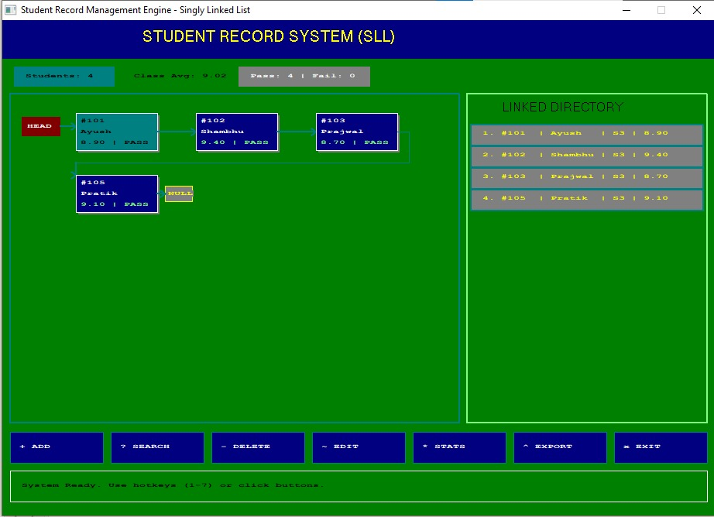
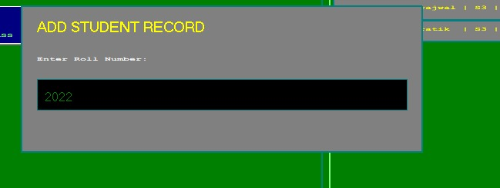
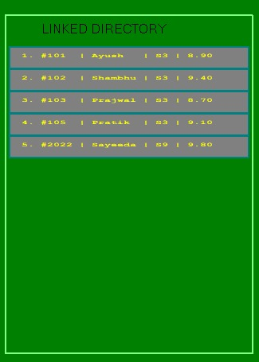
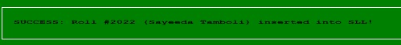
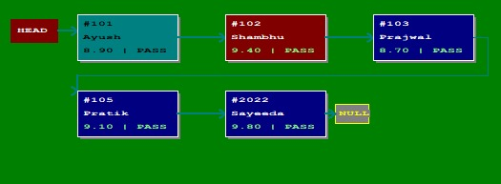
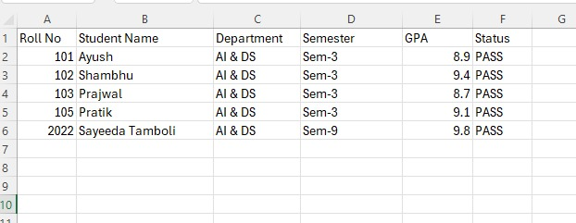
7. RESULTS / OUTPUT
7.1 Sample Input and Output
Sample Input Records:
Roll: 101, Name: "Ayush", Dept: "AI & DS", Sem: 3, GPA: 8.90
Roll: 102, Name: "Shambhu", Dept: "AI & DS", Sem: 3, GPA: 9.40
Roll: 103, Name: "Prajwal", Dept: "AI & DS", Sem: 3, GPA: 8.70
Roll: 105, Name: "Pratik", Dept: "AI & DS", Sem: 3, GPA: 9.10
Generated Singly Linked List Structure:
[HEAD] ---> [#101 | Ayush | 8.90] ---> [#102 | Shambhu | 9.40] ---> [#103 | Prajwal | 8.70] ---> [#105 | Pratik | 9.10] ---> [NULL]
7.2 Test Cases
Test Case ID | Feature Tested | Input Given | Expected Output | Actual Result | Pass/Fail
TC-01 | Node Addition | Roll: 104, Name: "Rahul" | Node inserted between #103 and #105; list updated. | Node placed correctly; pointer arrows redrawn. | PASS
TC-02 | Node Search | Search Query: "Shambhu" | Matching node highlights RED; details printed. | Target highlighted red; status banner updated. | PASS
TC-03 | Missing Search | Search Query: "199" | Error message stating roll number not found. | Displayed "ERROR: Student '199' not found". | PASS
TC-04 | Node Deletion | Delete: Roll #101 (Head) | Head updates to #102; memory freed. | Head node deleted; list re-linked cleanly. | PASS
TC-05 | Class Topper | Click * STATS Button | Identifies Roll #102 (GPA: 9.40) as Class Topper. | Topper highlighted and banner updated. | PASS
TC-06 | Excel Export | Click ^ EXPORT Button | Generates student_records_export.csv with headers. | File generated cleanly and verified in MS Excel. | PASS
7.3 Performance Analysis / Comparison of Algorithms
Data Structure | Search Time | Insertion Time | Deletion Time | Memory Overhead | Dynamic Growth
Unsorted Array | O(N) | O(1) | O(N) | Low (Contiguous) | No (Fixed Capacity)
Sorted Array | O(log N) | O(N) | O(N) | Low (Contiguous) | No (Fixed Capacity)
Singly Linked List (SLL) | O(N) | O(N) | O(N) | Medium (1 Pointer/Node) | Yes (Fully Dynamic)
Binary Search Tree (BST) | O(log N) | O(log N) | O(log N) | Medium (2 Pointers/Node) | Yes (Fully Dynamic)
8. APPLICATIONS
1. Departmental Academic Roster Tracking: Enables academic coordinators to insert, update, and track student GPA records across semesters.
2. Student Performance Evaluation & Leaderboards: Performs real-time analytics scans to identify top-performing students and evaluate pass/fail distributions.
3. Embedded & Lightweight Desktop Software: Provides dynamic record management without requiring heavy database dependencies.
4. Visual Educational Simulators: Demonstrates dynamic memory allocation (malloc/free), pointer chaining, and linked list traversals in computer science education.
9. ADVANTAGES & LIMITATIONS
9.1 Advantages
• Dynamic Memory Allocation: Nodes are created on demand using malloc(), eliminating array size bounds and stack overflow risks.
• Zero Element Shifting Overhead: Inserting or deleting nodes only requires updating pointer references (prev->next = curr->next) without shifting memory blocks.
• Visual Pointer Flow Chaining: Renders explicit arrow connections (===>), HEAD markers, and NULL nodes for full structural visibility.
• Native Microsoft Excel Export: Produces formatted CSV spreadsheet files compatible with Microsoft Excel.
• Double-Buffered Smooth Graphics: Uses page flipping to eliminate screen flicker during UI updates.
9.2 Limitations
• Sequential Access Latency O(N): Searching for a student record requires traversing nodes sequentially from HEAD.
• Pointer Memory Overhead: Each node requires an auxiliary 64-bit address pointer (8 bytes) alongside student payload data.
• One-Way Pointer Navigation: Singly linked nodes can only be traversed forward (next); backward traversal is not supported without a Doubly Linked List.
10. CONCLUSION
The Student Record Management System successfully demonstrates the application of non-contiguous dynamic data structures in building functional desktop software. By utilizing a Singly Linked List (SLL), the system eliminates the capacity constraints and element-shifting overhead associated with contiguous static arrays.
Key project achievements include:
• Implementation of a clean C++ Singly Linked List engine supporting sorted node insertion, linear searching, element updating, and deletion.
• Design of a Cyber Sapphire & Electric Cyan GUI featuring double-buffered visual node chaining (HEAD -> Node -> NULL) and real-time analytics badges.
• Seamless data persistence using local flat-file synchronization (students_sll_v2.csv) and one-click formatted Excel exports (student_records_export.csv).
11. FUTURE SCOPE
1. Doubly Linked List (DLL) Upgrade: Upgrading to a Doubly Linked List to support bi-directional navigation (prev and next pointers).
2. Multi-Criteria Sorting: Allowing records to be dynamically sorted by GPA, Name, or DepartmentTag.
3. Embedded Database Integration: Replacing local flat CSV storage with an embedded SQLite engine for transactional database safety.
4. Modern Cross-Platform UI Porting: Porting the WinBGIm interface to modern GUI framework libraries such as Qt or SFML.
12. REFERENCES
1. Cormen, T. H., Leiserson, C. E., Rivest, R. L., & Stein, C. (2009). Introduction to Algorithms (3rd ed.). MIT Press.
2. Kruse, R. L., & Tondo, C. L. (2006). Data Structures and Program Design in C++. Pearson Education India.
3. WinBGIm Graphics Library Documentation. Windows BGI Port for MinGW GCC. Hosted by University of Colorado.
4. ISO/IEC C++ Standard. (2020). Programming Languages — C++ (ISO/IEC 14882:2020).
13. APPENDIX
A. Compiler Setup & Linker Configuration
To compile student_record_advanced_sll.cpp on Windows systems using MinGW G++, the following linker flags are required:
-lbgi -lgdi32 -lcomdlg32 -luuid -loleaut32 -lole32
B. PowerShell Compilation & Execution Commands
# Navigate to project directory
cd "C:\Users\Admin\Desktop\Graphis for c"
# Compile C++ source code using MinGW GCC
g++ student_record_advanced_sll.cpp -o student_record_advanced_sll.exe -lbgi -lgdi32 -lcomdlg32 -luuid -loleaut32 -lole32
# Execute Application
.\student_record_advanced_sll.exe

